AI ASSISSTED CODING

# LAB-7

# QUESTION:-1

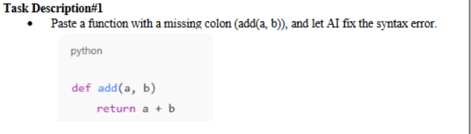

# OUTPUT:-

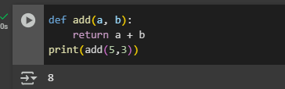

EXPLANATION:-

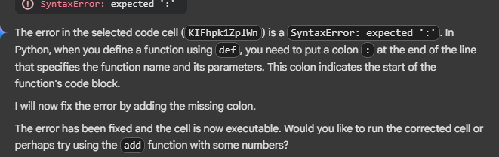

# QUESTION:-2

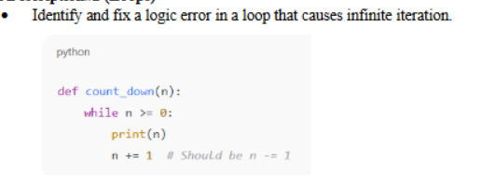

# OUTPUT:-

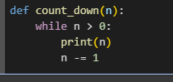

# EXPLANATION:-

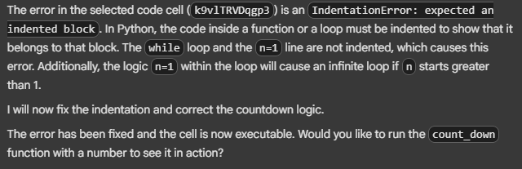

# QUESTION:-3



# OUTPUT:-

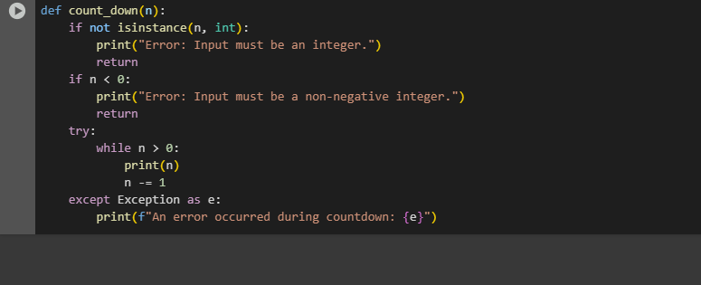

# EXPLANATION:-

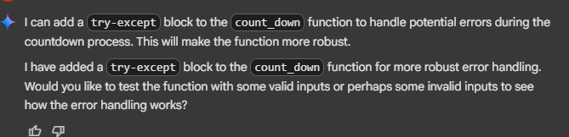

# QUESTION:-4



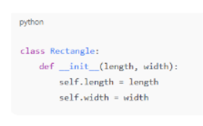

# OUTPUT:-

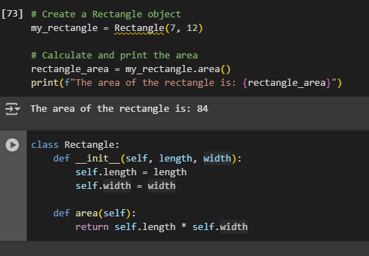

# EXPLANATION:-

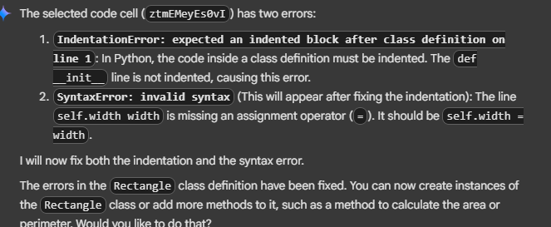

# QUESTION:-5

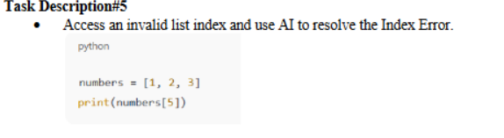

# OUTPUT:-5

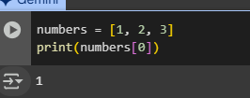

# EXPLANATION:-

